**1. Introduction**

* 1. **About System :-**

The Graphical Representation of Stack and Queue Represents the Data Structure concepts.

A stack is a container of objects that are inserted and removed according to the last-in first-out (LIFO) principle.

A queue is a container of objects (a linear collection) that are inserted and removed according to the first-in first-out (FIFO) principle.

* 1. **About Software Platform Used :**

**INTRODUCTION TO C:-**

C is a general-purpose high level language that was originally developed by Dennis Ritchie for the Unix operating system. It was first implemented on the Digital Equipment Corporation PDP-11 computer in 1972.

The Unix operating system and virtually all Unix applications are written in the C language. C has now become a widely used professional language for various reasons..

**Why to use C ?**

C was initially used for system development work, in particular the programs that make-up the operating system. C was adopted as a system development language because it produces code that runs nearly as fast as code written in assembly language. Some examples of the use of C might be:

* Operating Systems
* Language Compilers
* Assemblers
* Text Editors
* Print Spoolers
* Network Drivers
* Modern Programs
* Data Bases
* Language Interpreters
* Utilities

C Program File

All the C programs are written into text files with extension ".c" for example *hello.c*. You can use "vi" editor to write your C program into a file.

This tutorial assumes that you know how to edit a text file and how to write programming instructions inside a program file.

A C program basically has the following form:

* Preprocessor Commands
* Functions
* Variables
* Statements & Expressions
* Comments

**Features of C Programming Language :-**

**1.** **Low Level Features :-**

* C Programming provides [low level features](http://www.c4learn.com/c-programming/low-level-language/) that are generally provided by the Lower level languages. C is Closely Related to Lower level Language such as “Assembly Language“.
* It is easier to [write assembly language codes in C programming](http://c4learn.com/c-programs/mixing-inline-assembly-program-in-c.html).

**2. Portability :-**

* C Programs are portable i.e they can be run on any Compiler with Little or no Modification
* Compiler and Pre-processor make it Possible for C Program to run it on Different PC

**3. Powerful:-**

* Provides Wide verity of ‘Data Types‘
* Provides Wide verity of ‘Functions’
* Provides useful Control & Loop Control Statements

**4. Bit Manipulation:-**

* C Programs can be manipulated using bits. We can perform different operations at bit level. We can manage memory representation at bit level. [E.g. [We can use Structure to manage Memory at Bit Level](http://www.c4learn.com/c-programming/c-structure-bit-manipulation/)]
* It provides wide verity of bit manipulation Operators. We have bitwise operators to manage Data at bit level.

**5. High Level Features :-**

* It is more User friendly as compare to Previous languages. Previous languages such as BCPL, Pascal and other programming languages never provide such great features to manage data.
* Previous languages have their pros and cons but C Programming collected all useful features of previous languages thus C become more effective language.

**6. Efficient Use of Pointers:-**

* Pointers has direct access to memory.
* C Supports efficient use of pointer.

**Disadvantages of C Programming Language:**

* C Programming Language doesn't support Object Oriented Programming (OOP) features like Inheritance, Encapsulation, Polymorphism etc. It is a procedure oriented language. In C, we have to implement any algorithms as a set of function calls.
* C doesn't perform Run Time Type Checking. It only does compile time type checking. At run time, C doesn't ensure whether correct data type is used instead it perform automatic type conversion.
* C does not provides support for namespace like C++. Without Namespace, we cannot declare two variables of same name.
* C doesn't support the concept of constructors and destructors.

**Turbo C features:-**

* Inline assembly with full access to the C language symbolic structures and names -- This allowed programmers to write some assembly language codes right into their programs without the need for a separate assembler.
* Support for all memory models -- This had to do with the segmented memory architecture used by 16-bit processors of that era, where each segment was limited to 64 kilobytes (Kb).
* Speed or size optimization -- The compiler could be configured to produce an executable program that was either fast or small in size, but not both.
* Constant folding -- This feature allowed the Turbo C compiler to evaluate constant expressions during compile time rather than during run time.

**Introduction to Graphics:-**

The main purpose of introducing graphics at this stage is to demonstrate how important it is to learn functions.

All the example programs given here, work only in Turbo C platform because functions like clrscr(), textcolor(), cprintf()and delay() are not available in other platforms.

**Graphics in C language**

Display can be normally used in either text mode or graphic mode. In text mode the screen is divided into 80 columns and 25 rows. In case of graphic mode the total screen is divided into 640 pixels width and 480 pixels height. Latest displays are even rich in resolution.

Generally text displays are faster then graphic displays because in graphic mode we have to program pixel by pixel. Here in this session, we are going to learn graphics in text mode. It may be help full in developing simple applications and games.

1. **gotoxy():-**

gotoxy()  is a function used to send the cursor to the specified coordinates in the active window. Here the first coordinate is the column (x) and the second coordinate is the row (y). Here it accepts relative coordinates to the current active window

**Syntax:-** gotoxy(int x ,int y)

1. **textcolor():-**

textcolor() is the function used to set the foreground (text) color in the active window. We can use either numeric value or symbolic name to set the text color.

**Syntax:-** textcolor(RED);

1. **textbackground():-**

textbackground() is the function used to set the background color to the active window. It accepts either numeric color value or symbolic name as argument.

1. **delay():-**

It is the function defined in **dos.h**, used to delay the execution for specified number of milliseconds.

1. **outtextxy():**

void outtextxy(int x, int y, char *string); These functions are used to display text on the screen in graphics mode. Function outtext displays text at the current position while outtextxy displays text at the specified coordinates (x, y) on the screen.

**Syntax:-** void outtextxy(int x, int y, char *string);

# setcolor ():

The header file graphics.h contains **setcolor()** function which is used to set the current drawing color to the new color.

**Syntax :** void setcolor(int color);

1. **bar() :**

The header file graphics.h contains **bar()** function which is used to draw a 2-dimensional, rectangular filled in bar.

**Syntax:-** void bar(int left, int top, int right, int bottom

1. **rectangle():**

**rectangle()** is used to draw a rectangle. Coordinates of left top and right bottom corner are required to draw the rectangle. left specifies the X-coordinate of top left corner, top specifies the Y-coordinate of top left corner, right specifies the X-coordinate of right bottom corner, bottom specifies the Y-coordinate of right bottom corner.

**Syntax :-** rectangle(int left, int top, int right, int bottom

1. **setfillstyle():**

The header file graphics.h contains **setfillstyle()** function which sets the current fill pattern and fill color.

**Syntax:** void setfillstyle(int pattern, int color)

1. **floodfill():**

**floodfill()** function is used to fill an enclosed area. Current fill pattern and fill color is used to fill the area.

**Syntax:-** void floodfill(int x, int y, int border);

1. **line():**

line function is used to draw a line from a point(x1,y1) to point(x2,y2) i.e. (x1,y1) and (x2,y2) are end points of the line.The code given below draws a line.

**Syntax:-** void line(int x1, int y1, int x2, int y2

# cleardevice() :

The header file graphics.h contains **cleardevice()** function which clears the screen in graphics mode and sets the current position to (0,0). Clearing the screen consists of filling the screen with current background color.

**Syntax :** void cleardevice();

**1.3 OPERATING ENVIRONMENT - HARDWARE & SOFTWARE**

**HARDWARE:**

* 1 GB Hard Disk
* Minimum 256 RAM
* Key Board : 108 keys
* Monitor :SVGL color

**SOFTWARE:**

1. Operating system : Any Windows-OS

2. Application Software :

Text Editor

Notepad

Turbo C++

**2. Analysis**

**2.1 System design (Site Map) :-**

Graphical Representation of

Stack of Queue

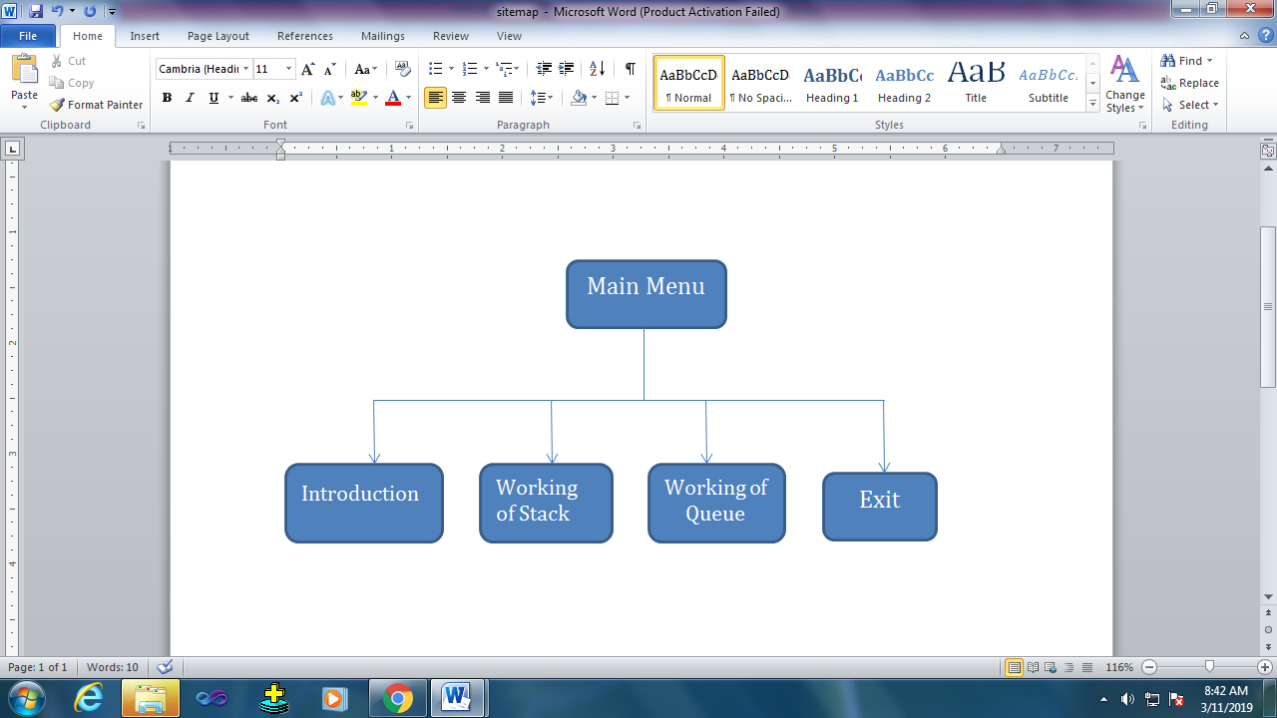

**\**

**4. Input and Output Design**

1. **Main Menu :-**

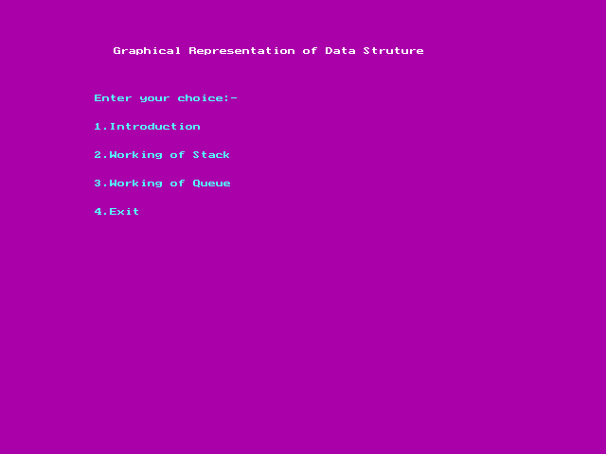

1. **Introduction**

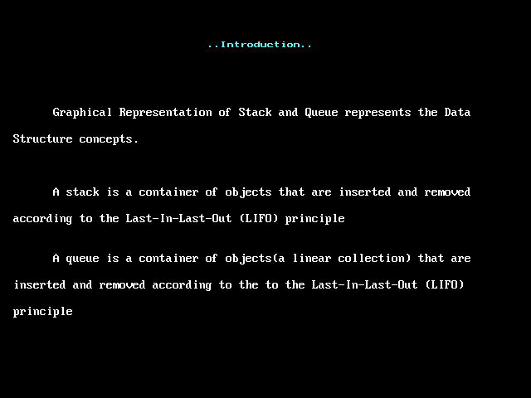

Selecting Stack

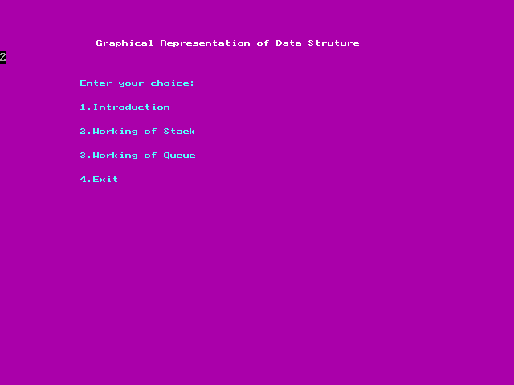

**Entering choice:- (1. Push)**

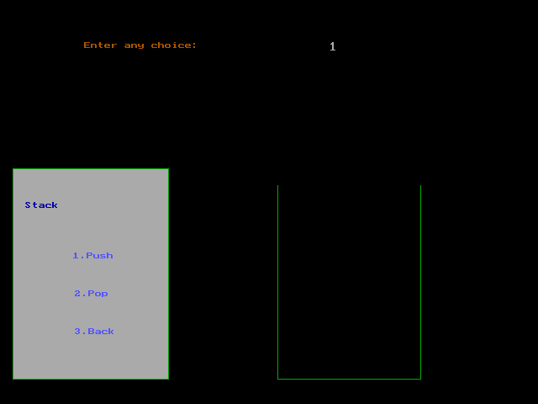

**Entering Any Number**

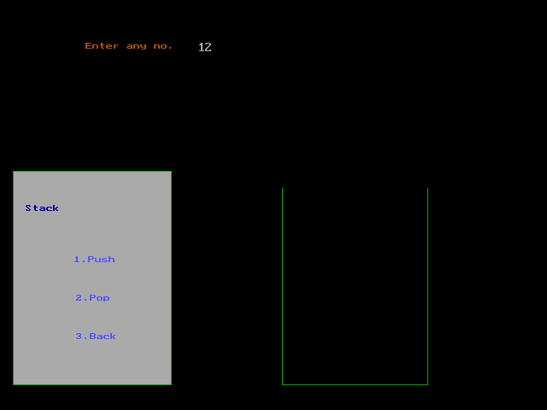

**Value Moving into Stack**

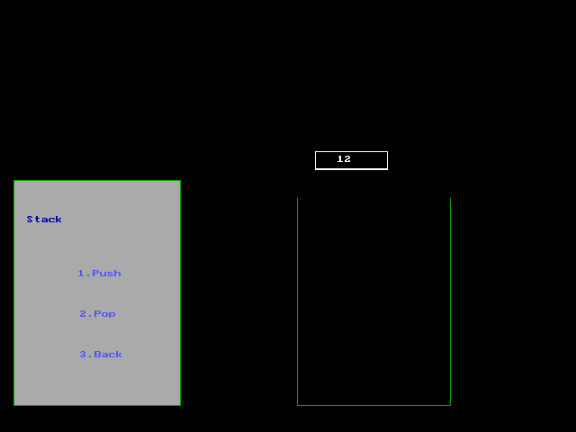

**Value in Stack**

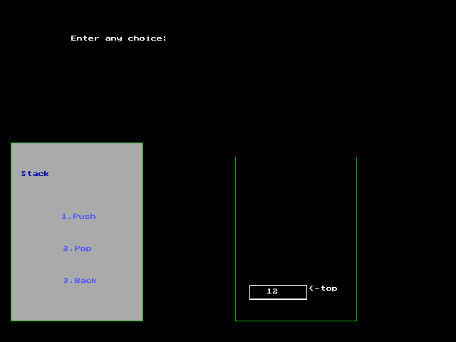

**Stack Overflow**

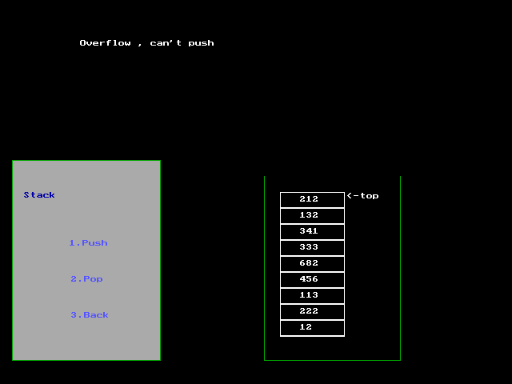

**Enter Choice :- (2. Pop)**

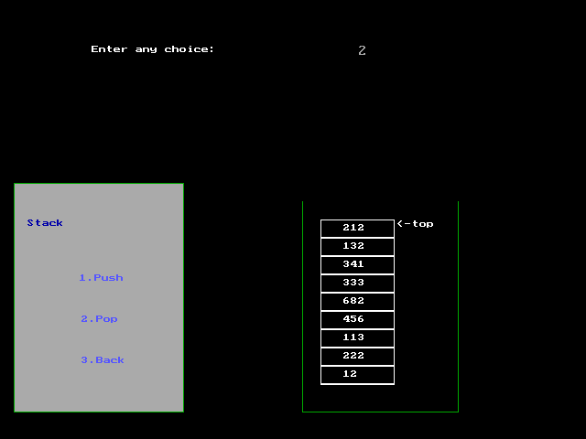

**Element Popped (removed) from Stack**

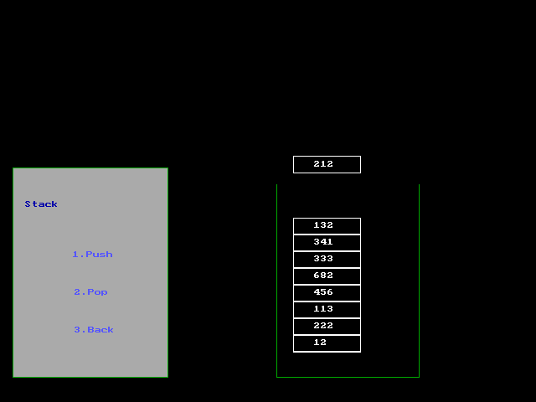

**Stack Underflow**

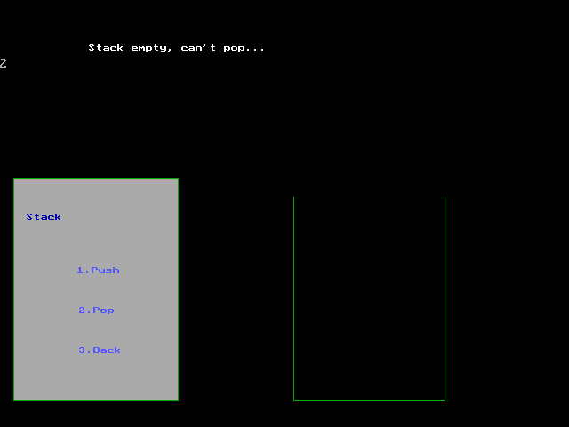

**Choice to go Back**

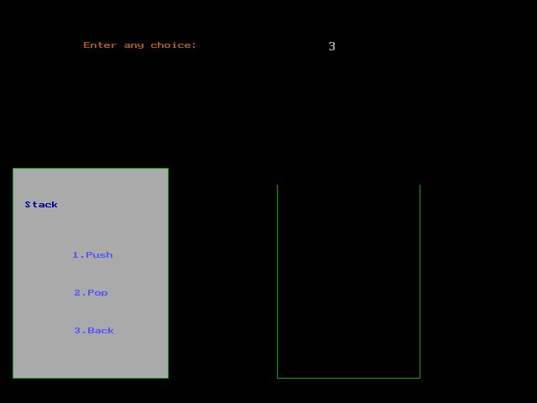

**Enter Choice (1. Insert)**

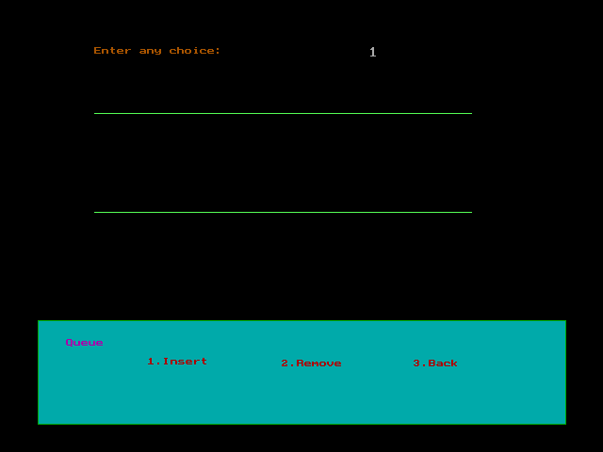

**Enter Element**

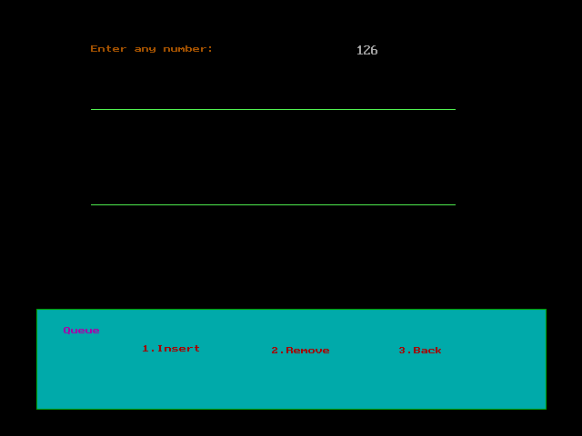

**Element moving into Queue**

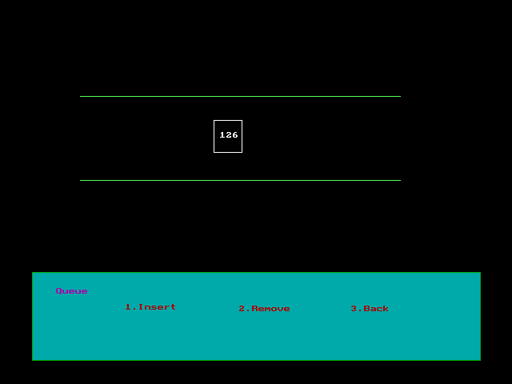

**Element inserted into Queue**

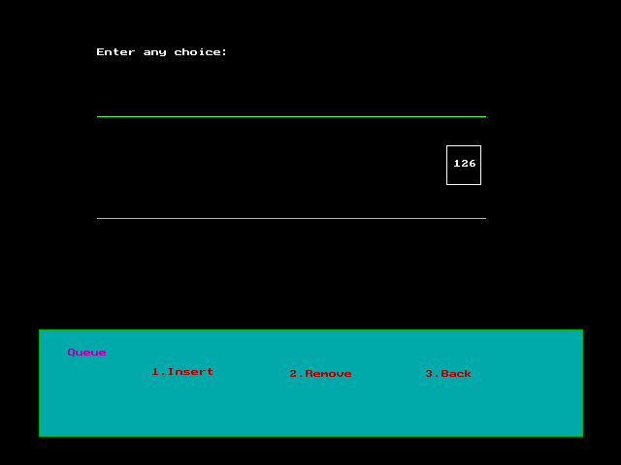

**Condition of Queue - full**

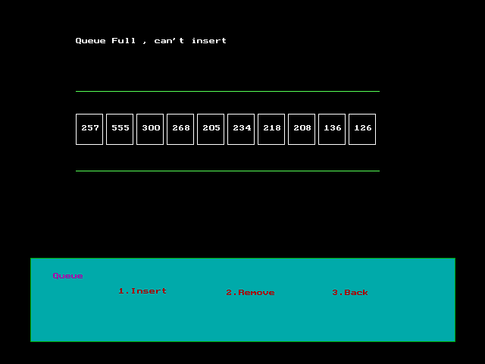

**Choice to Remove Element ( 2. Remove):-**

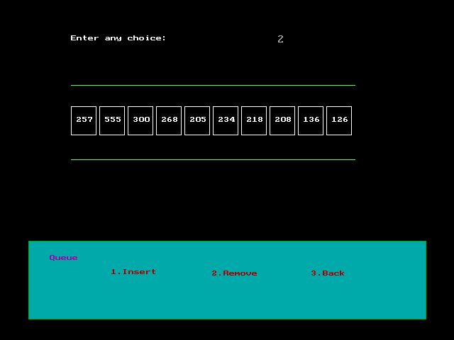

**Element moving out of Queue**

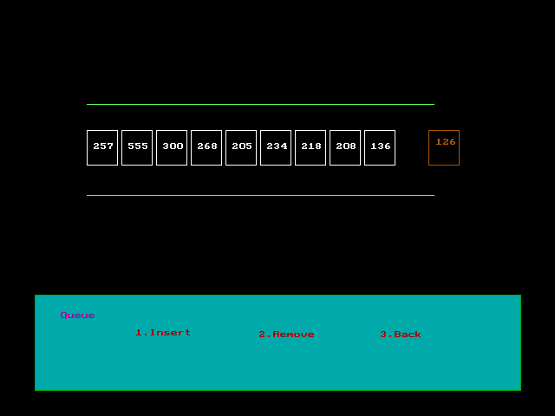

**Element changing their position**

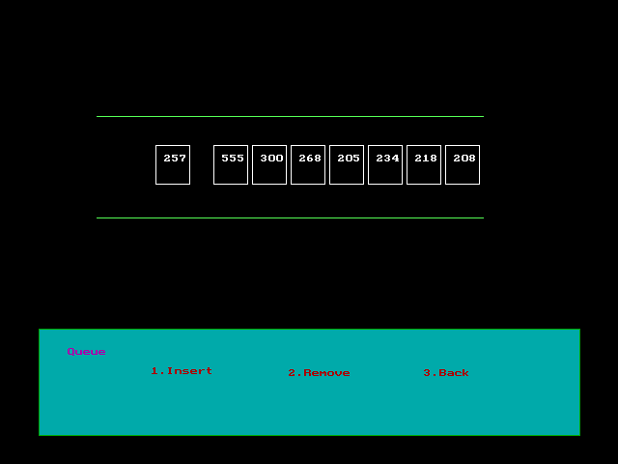

**Queue Underflow**

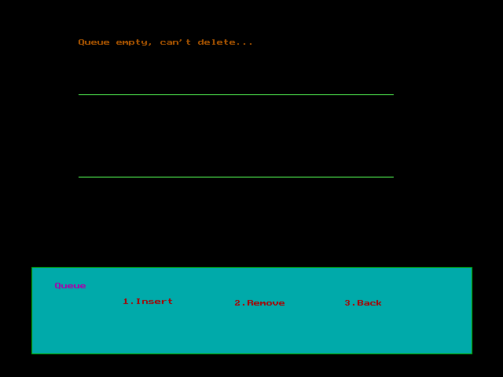

Choice to go Back

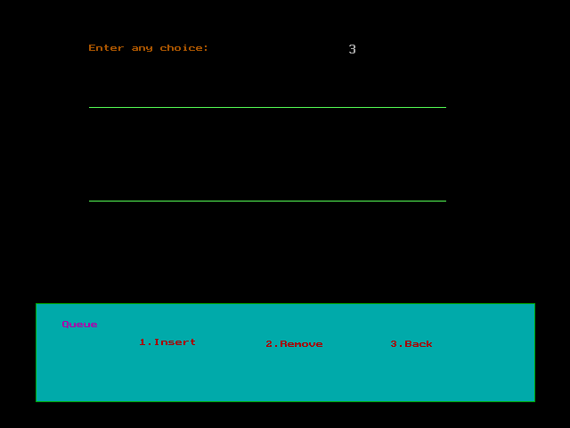

**EXIT (Enter choice 4 for exit)**

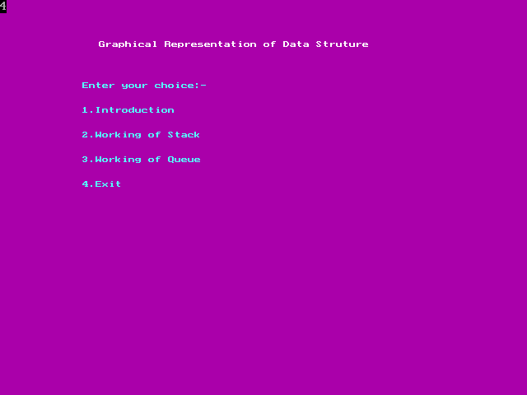

**3. Coding**

1. **Header Files & global Declaration :-**
2. **Main Function**

#include<stdio.h>

#include<graphics.h>

#include<conio.h>

#include<dos.h>

#include<stdlib.h>

#include"intro2.h"

int i,j,ch;

int count=0;

int counts=0;

char n[10];

char elements[10][10];

char qelements[10][10];

void push();

void pop();

void stack();

void insert(); void rem();

void queue();

int front=0;

int rear=0;

void insert()

{

int j=0;

bar(100,50,500,100);

outtextxy(100,50,"Enter any number: ");

gotoxy(50,4);

scanf("%s",qelements[rear++]);

bar(50,30,500,100);

j=60-20*(count-1);

for(i=0;i<=420-20*count ;i++)

{

setcolor(0);

bar(j-1+i,150,j+34+i,190);

setcolor(15);

rectangle(j+i,150,j+35+i,190);

outtextxy(j+8+i,165,qelements[rear-1]);

delay(5);

}

}

void rem()

{

int j=0;

j=401-20*(count-1);

for(i=460;i<=640 ;i++)

{

setcolor(2);

bar(i,150,i+35,190);

setcolor(6);

rectangle(i+1,150,i+36,190);

outtextxy(i+10,160,qelements[front]);

delay(5);

}

for(j=1;j<(rear-front);j++)

{

for(i=460-j*40;i<=460-(j-1)*40 ;i++)

{

setcolor(0);

bar(i,150,i+35,190);

setcolor(15);

rectangle(i+1,150,i+36,190);

outtextxy(i+10,160,qelements[front+j]);

delay(5);

}

}

front++;

}

void queue()

{

setcolor(6);

setfillstyle(1,3);//8small rectangle fill colour

setcolor(2); //small r. border colour

rectangle(15,340,500,450); //rectangle size

floodfill(19,350,2);

//setfillstyle(1,9);

//floodfill(150,150,10);

//setfillstyle(1,2);

bar(70,370,150,400);

setcolor(7); //color of text

outtextxy(30,360,"Queue"); //To enter text

setcolor(6);

//outtextxy(220,60,"Enter number:-");

setcolor(4);

//setfillstyle(1,2);

bar(70,370,150,400);

outtextxy(157,380,"1.Insert");

bar(70,370,150,400);

outtextxy(259,382,"2.Remove");

bar(70,370,150,400);

outtextxy(379,382,"3.Back");

setcolor(10); //2line color

line(100,120,500,120);

line(100,225,500,225);

setfillstyle(1,2);

setcolor(6);

setfillstyle(1,0);

j=1;

do

{

bar(100,50,500,100);

outtextxy(100,50,"Enter any choice: ");

gotoxy(50,4);

scanf("%d",&ch);

bar(50,30,500,100);

switch(ch)

{

case 1:if(rear==8)

{

outtextxy(100,50,"Queue Full , can't insert ");

getch();

}

else

{

count++;

insert();

}

break;

case 2:if(count>0)

{

count--;

rem();

}

else

{

// rem();

outtextxy(100,50,"Queue empty, can't delete... ");

getch();

}

break;

case 3: cleardevice();

break;

}

}while(ch!=3);

}

void main()

{

int gd=DETECT,gm;

int n;

int ch,mch;

initgraph(&gd,&gm,"c:\\turboc3\\bgi");

//Main menu

do

{

setfillstyle(1,5);//8small rectangle fill colour

setcolor(15); //small r. border colour

floodfill(19,350,1);

setfillstyle(0,1);

outtextxy(120,50,"Graphical Representation of Data Struture");

setcolor(11);

outtextxy(100,100,"Enter your choice:-");

outtextxy(100,130,"1.Introduction");

outtextxy(100,160,"2.Working of Stack");

outtextxy(100,190,"3.Working of Queue");

outtextxy(100,220,"4.Exit");

scanf("%d",&mch); //

clrscr();

switch(mch)

{

case 1:intro();

break;

case 2:cleardevice();

stack();

break;

case 3:cleardevice();

queue();

break;

case 4:break;

}

}while(mch!=4);

}

///////////////////////////////////////////////////////////////Stack//////////////////////////////////////////////////////////

void pop()

{

int j=0;

j=401-20*(counts-1);

for(i=0;i<=340-20*counts ;i++)

{

bar(350,j-2-i,475,j+18-i);

setcolor(15);

rectangle(350,j-3-i,430,j+17-i);

outtextxy(375,j+3-i,elements[counts-1]);

delay(5);

}

if(counts>1)

outtextxy(436,j+20,"<-top");

if(counts==1)

bar(350,420,450,422);

bar(325,220,550,140);

}

void push()

{

outtextxy(100,50,"Enter any no.");

gotoxy(30,4);//to input number...

scanf("%s",n);

strcpy(elements[counts],n);

bar(50,30,400,100);

j=counts;

for(i=0;i<=300-20*j;i++)

{

bar(350,98+i,470,118+i);

setcolor(15);

rectangle(350,100+i,430,120+i);

outtextxy(375,105+i,n);

delay(5);

}

outtextxy(434,100+i,"<-top");

bar(434,120+i,473,140+i);

j++;

}

void stack()

{

setcolor(6);

setfillstyle(1,7);//small rectangle fill colour

setcolor(2); //small r. border colour

rectangle(15,200,200,450); //rectangle size

floodfill(19,210,2);

bar(70,370,150,400);

setcolor(1); //color of text

outtextxy(30,240,"Stack"); //To enter text

setcolor(4);

//outtextxy(220,60,"Enter number:-");

setcolor(9);

//setfillstyle(1,2);

bar(70,370,150,400);

outtextxy(87,300,"1.Push");

bar(70,370,150,400);

outtextxy(89,345,"2.Pop");

bar(70,370,150,400);

outtextxy(89,390,"3.Back");

setcolor(2);

line(330,450,500,450);

line(330,450,330,220);

line(500,220,500,450);

setfillstyle(1,2);

setcolor(6);

setfillstyle(1,0);

j=1;

do

{

bar(100,50,500,100);

outtextxy(100,50,"Enter any choice: ");

gotoxy(50,4);

scanf("%d",&ch);

bar(50,30,500,100);

switch(ch)

{

case 1:if(j==9)

{

outtextxy(100,50,"Overflow , can't push ");

getch();

}

else

{

push();

counts++;

}

break;

case 2:if(counts>0)

{

pop();

counts--;

}

else

{

outtextxy(100,50,"Stack empty, can't pop... ");

getch();

}

break;

case 3: cleardevice();

break;

}

}while(ch!=3);

}

1. **Intro2.h**

void intro()

{

cleardevice();

//clrscr();

settextstyle(8,0,1);

outtextxy(250,50,"..Introduction..");

settextstyle(2,0,4);

printf("\n\n\n\n\n\n\n\nGraphical Representation of Stack and Queue represents the Data");

printf("Structure concepts.");

printf("A stack is a container of objects that are inserted and removed according to the");

printf("to the Last-In-Last-Out (LIFO) principle");

printf("A queue is a container of objects(a linear collection) that are inserted and removed according to the");

printf("to the Last-In-Last-Out (LIFO) principle");

getch();

cleardevice();

}

**5. User Manual**

The system is named as Graphical Representation of Stack and Queue. This

System is used to make clear of Stack and Queue.

It contains the following :-

1. **Introduction :-**

It gives a brief introduction of the working of Stack and Queue. Press ‘1’ to get Introduction.

1. **Working of Stack:-**

It shows about how the Stack works. Press ‘2’ to see the graphical working of Stack.

1. **Working of Queue:-**

It shows about how the Queue works. Press ‘3’ to see the graphical working of Queue.

1. **Exit:-**

If you press 4, then you will Exit.

**7. Limitation and Future Enhancement**

**Limitation:-**

* This system is graphics based only.
* This system does not support File Handling.
* This system follows Static Memory Allocation.

**Future Enhancement:-**

* The system only representation the working of few Data Structure concepts viz. Stack and Queue. The working of Linked List, Double Linked List will be enhanced in future.
* The system only represents the working of Linear Queue only. The working of Circular and Priority Queue will be enhanced in near future.

**6. Conclusion**

* We designed the Graphical Representation of Stack of Queue, mainly makes clear the concepts easy.
* Representing the Data Structure concepts had helped us to get knowledge about the working of Stack and Queue.
* In the development of this project we have learned the importance of C as well as graphics related activities.
* We have used Turbo C++ to create this system. Which is used for system development work.

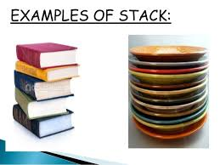 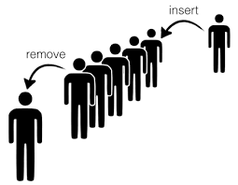

**6. Bibliography**

**Reference Books:-**

* **Let Us C**
* Yashwant Kanetkar
* **C Programming Language (2nd Edition)**
* B. W. Kernighan & D. M. Ritchie
* **Project using C**
* PVN. Varalakshmi.
* **Data Structure using C**
* Shilpa Pawale.

**Website**:-

* [WWW.w3school.com](http://www.w3school.com/)
* [www.wekipedia.com](http://www.wekipedia.com/)
* [https://stackoverflow.com](https://stackoverflow.com/)